**<**rachel-meadows/**>**

**<**rachel-meadows/**>**

**<**rachel-meadows/**>**

**<**rachel-meadows/**>**

**<**rachel-meadows/**>**

**<**rachel-meadows/**>**

**<** rachel-meadows **/>**

Junior full-stack developer

**<** rachel-meadows **/>**

Full-stack developer

**<** rachel-meadows **/>**

Full-stack developer (Jr)

**<** **R />**

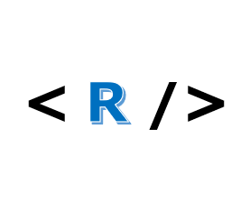



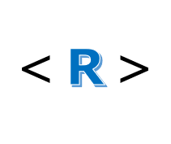



< **R** >



